Student J

Grader J

Project 2

Well done!

Here's your code:

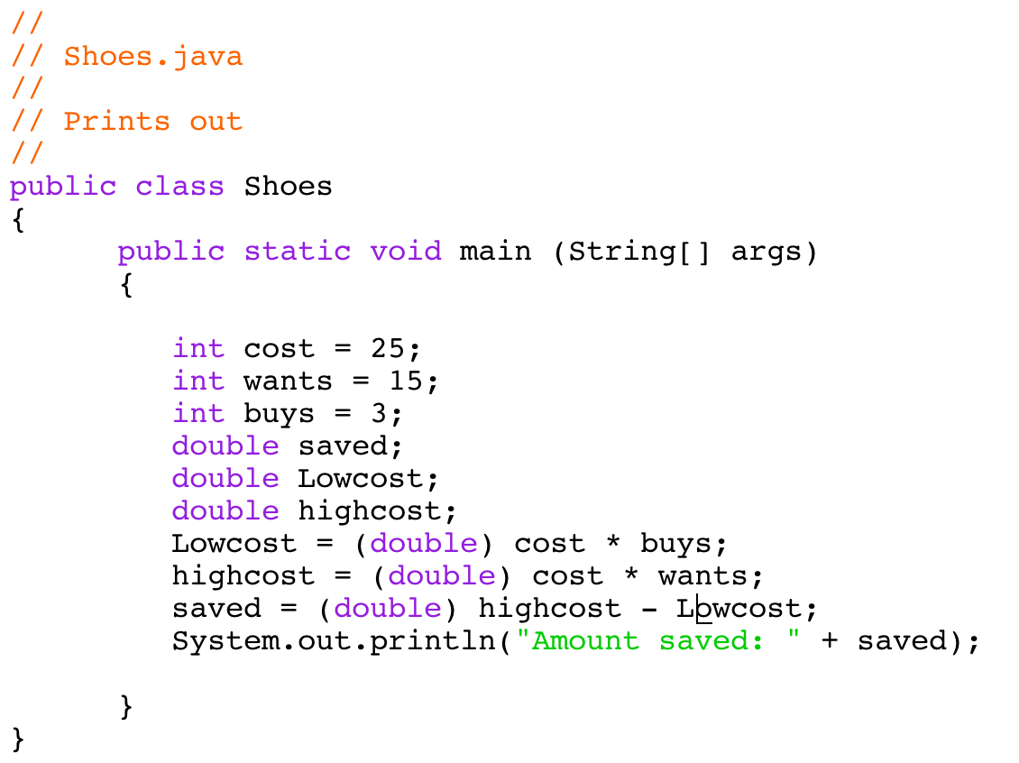

Here's the output:

